BARBERA 2010
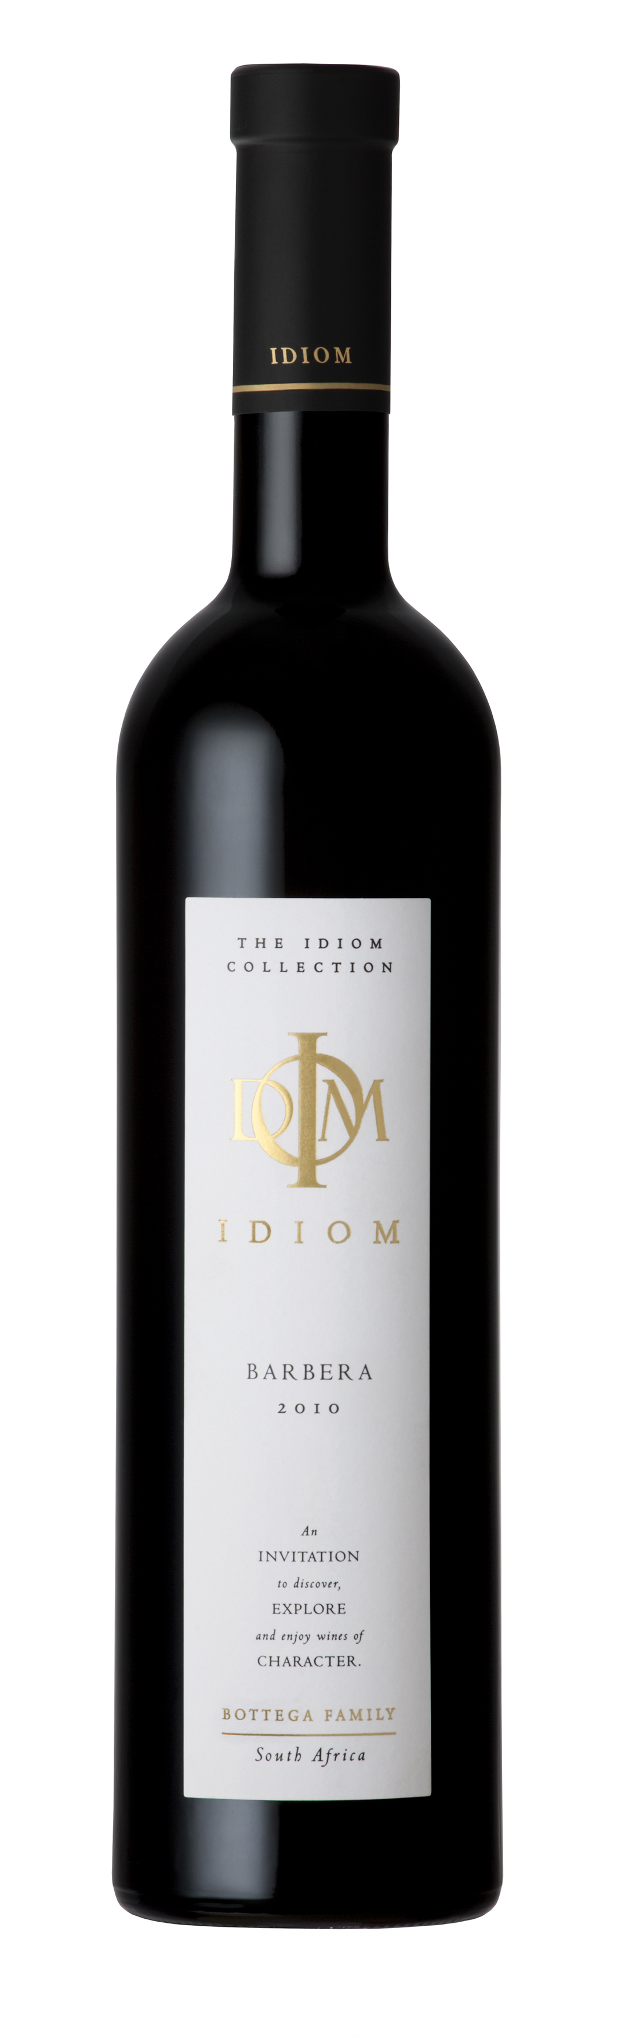
VINIFICATION
Wine maker description | A grape varietal originating from the Piedmont region of Italy known for its deep colour, low tannins and high natural acidity. This refreshing Stellenbosch Barbera from low yielding vineyards has typical intense aromas of red and blackcurrant and offers hints of cedar wood and spice. A rich wine with a vibrant finish.
Varieties | 100 % Barbera
Origin | Wine of Origin Stellenbosch
Vinification details | Grapes where crushed into bin liners for fermentation, after which it was pressed in a small basket press straight into 225L French oak barrels and then matured for 24 months. The wine was bottled by hand without filtration, and may contain sediment.
Date of bottling | 10th February 2012
Analysis | pH 3.82 Total acidity 5.9 g/l  Residual sugar 2.7 g/l Alcohol %14
PROVENANCE
Vineyard – Da Capo, Sir Lowry’s Pass, Helderberg

Soils | Granite/Tukulu (decomposed granite)/Table Mountain Sandstone
Aspect | North west
Area | 1 Ha
Trellising | Vertical Shoot Positioning
Irrigation | Drip
Predominant wind | SE Summer/NW Winter
Date of planting | February 2006
Clones | BB1
Balling at picking | 23,7 °B

