ZINFANDEL
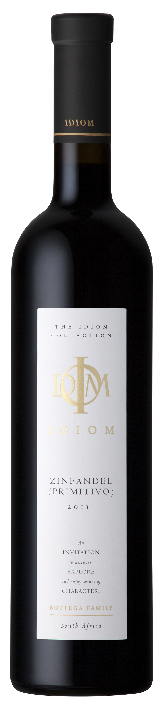
2011
VINIFICATION
Wine maker description | A powerful wine typical of our exotic Zinfandel. Aromas of bayleaf and dried rosemary dominate the nose. Intense, evolving flavours of biltong, liquorice and black currants stimulate the palate. The Usual smooth long lingering finish invites further participation.
Origin | Wine of Origin Stellenbosch
Vinification details | Following two days of cold maceration the grapes rose to temperatures of between 25 & 28°C throughout fermentation. Twice daily the grapes were punched down by hand in their stainless steel fermentation tanks. 30% American oak and 70% French oak was used, where the wine completed malolactic fermentation and maturation for a further 12 months.
Date of bottling | 18th of January 2013
Analysis | pH 3.74 Total acidity 5.2 g/l  Residual sugar 2.6 g/l Alcohol 15.5 %
PROVENANCE
Vineyard – Da Capo, Sir Lowry’s Pass, Helderberg

Soils | Granite/Tukulu (decomposed granite)/Table Mountain Sandstone
Aspect | North west
Area | 1.17 Hectares
Trellising | Vertical Shoot Positioning
Irrigation | Drip
Predominant wind | SE Summer/NW Winter
Date of planting | 2002
Clones | ZD1AXA on R110
Balling at picking | 5.6 t/Ha

