900 SERIES
NEBBIOLO
2016

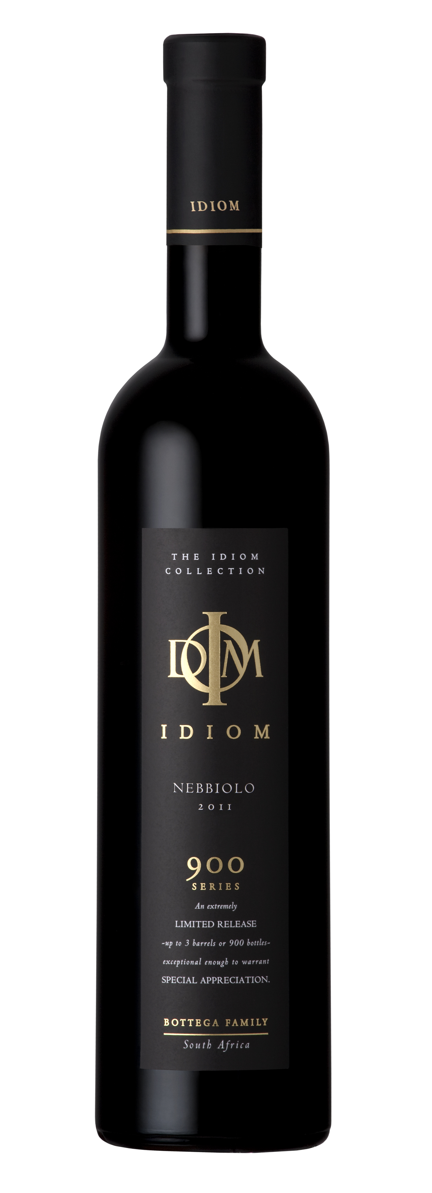
VINIFICATION
Wine maker description | A rich and noble red. This expression of Nebbiolo, from low yielding Stellenbosch vineyards, has a dark garnet colour, a ripe bouquet of red fruits and roses. Almond and plum flavours intermingle on the palate with hints of truffle and mushroom. The silky structured tannins indicate a wine that will reward cellaring.
Varieties | 100 % Nebbiolo
Origin | Wine of Origin Stellenbosch
Vinification details | Grapes are hand harvested into a fermentation bin. The grapes then spend 2days on cold maceration before being inoculated with the optimal yeast culture. Fermentation takes place in open top 500L French oak barrels for anything from 7-11days at temperatures of between 26-32°C. The grapes are then pressed with a small 50kg hand press before finishing MLF fermentation in 300L French oak barrels. The wine then matures in 300L French oak barrels for 24 months, before being lightly filtered and hand bottled.
Date of bottling | 18th November 2019
Analysis | pH 3.62 Total acidity 6.5 g/l  Residual sugar 2.1 g/l Alcohol 13.5%
PROVENANCE
Vineyard – Da Capo, Sir Lowry’s Pass, Helderberg

Soils | Granite/Tukulu (decomposed granite)/Table Mountain Sandstone
Aspect | North west
Area | 0.5 Ha
Trellising | Vertical Shoot Positioning
Irrigation | Drip
Predominant wind | SE Summer/NW Winter
Date of planting | 2003
Clones | NB1
Balling at picking | 24,3 °B

